

Student Name……………………………………

FURTHER MATHEMATICS

WRITTEN TRIAL EXAMINATION 2

2013

Reading Time: 15 minutes
Writing time: 1 hour 30 minutes

Instructions to students
This exam consists of Section A and Section B.
Section A contains a set of extended answer questions from the core, 'Data Analysis'.
Section A is compulsory and is worth 15 marks.
Section B begins on page 7 and consists of 6 modules. You should choose 3 of these modules and answer every question in each of your chosen modules. Each of the modules is worth 15 marks.
Section B is worth 45 marks.
There is a total of 60 marks available for this exam.
The marks allocated to each of the questions are indicated throughout.
Students may bring one bound reference into the exam.
An approved graphics or CAS calculator may be used in the exam.
Formula sheets can be found on pages 32 and 33 of this exam.
Unless otherwise stated the diagrams in this exam are not drawn to scale.

This paper has been prepared independently of the Victorian Curriculum and Assessment Authority to provide additional exam preparation for students. Although references have been reproduced with permission of the Victorian Curriculum and Assessment Authority, the publication is in no way connected with or endorsed by the Victorian Curriculum and Assessment Authority.

© THE HEFFERNAN GROUP 2013

This Trial Exam is licensed on a non transferable basis to the purchasing school. It may be copied by the school which has purchased it. This license does not permit distribution or copying of this Trial Exam by any other party.

SECTION A

Core

Question 1

This section is compulsory.

The histogram below shows the distribution of weights (in kg) of a squad of athletes.
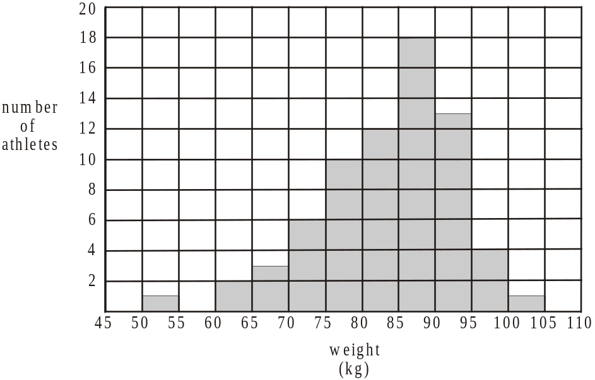

- How many athletes are in the squad?

1 mark

- Describe the shape of this histogram.

1 mark

- Find the percentage of athletes in the squad with a weight between 70 kg and 80 kg. Express your answer correct to one decimal place.

1 mark

Question 2

The heights (in cm) of the athletes in this squad are normally distributed with a mean of 176cm and a standard deviation of 5cm.

- Find the standardized height (expressed as a z-score) for one of the athletes who is 172cm tall.

1 mark

- Another athlete in the squad has a standardized height of 1. What percentage of the squad would be shorter than this athlete?

1 mark

Question 3

The weight, in kg, of 20 of the athletes together with the time in secs they take to run 400 metres are shown in the scatterplot below. A least squares regression line has been fitted to the data.
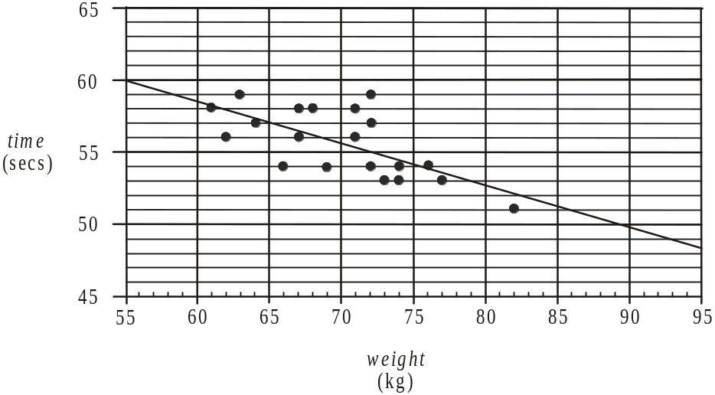

The equation of the least squares regression line for predicting time from weight is

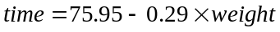

The correlation coefficient for this set of data is 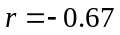.

- What is the independent variable?

1 mark

- Describe the relationship between the variables time and weight by making reference to strength and direction.

1 mark

- Using the least squares regression line equation, predict the time, in seconds, an athlete with a weight of 90kg would take to run 400 metres.

1 mark

- Explain why the prediction made in part c. is probably not reliable.

1 mark

- Find the percentage of variation in the time taken for an athlete to run 400m that can be explained by the variation in the weight of the athlete. Express your answer as a percentage correct to the nearest whole percent.

1 mark

The athlete who weighed 73kg ran a time of 53 seconds for the 400 metres.

- Find the residual value for this athlete if the least squares regression line is used to predict her time for running 400 metres.

2 marks

Question 4

The table below shows the monthly seasonal indices for the average number of hours spent training by squad members during 2012. The entry for September has been left out.

Monthly Seasonal Indices
Jan | Feb | Mar | Apr | May | Jun | Jul | Aug | Sep | Oct | Nov | Dec
0.6 | 0.7 | 0.8 | 1.1 | 1.0 | 0.9 | 1.2 | 1.4 |  | 1.6 | 1.1 | 0.4

In March 2012, the average number of hours spent training by squad members was 20 hours.

- Complete the entry for the monthly seasonal index for September in the table above.

1 mark

- Find the deseasonalised value for the average number of hours spent training by squad members in March 2012.

1 mark

- Explain what the monthly index of 1.2 means in terms of the average number of hours spent training by squad members during July.

1 mark
Total 15 marks

SECTION B

Module 1: Number patterns

If you choose this module all questions must be answered.

Question 1

In its first year of publication, 5 000 copies of a book were published. In its second year of publication 4 720 copies were published and in its third year 4 440 copies were published.
The number of copies of the book published each year formed an arithmetic sequence.

- Write down the common difference for this sequence.

1 mark

- How many copies of this book were published in its fifth year of publication?

1 mark

- How many books were published in total in the first decade of the book’s publication?

1 mark
If the number of copies of the book published each year was to exceed 1000, the publisher would continue to publish it.

- For how many years was the book published?

1 mark

The sequence that describes the number of copies of the book published in the nth year can be expressed using the difference equation

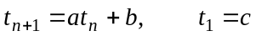

where represents the number of books published in the nth year of publication and a, b and c are constants.

- Write down the values of a, b and c.

2 marks

Question 2

In the first year that the book was published 4000 copies were sold. In the next year, 3800 copies were sold and in the third year 3610 copies were sold. The number of copies of the book sold in each year of the book’s publication forms a geometric sequence.

- Show that the common ratio for this sequence is .

1 mark

- How many copies were sold in the book’s ninth year of publication? Express your answer to the nearest whole number.

1 mark

- In which year of publication was the number of sales of the book equal to 2053 (correct to the nearest whole number).

1 mark

- If there were 45 600 copies of the book published in total, how many years would it take for the book to be sold out? Express your answer in years correct to 1 decimal place.

1 mark

Question 3

The number of ebooks, 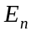, that a company predicts it will sell in its nth year of operation is modelled by the difference equation

- Find the number of ebooks that the company predicts to sell in its fifth year of operation.

1 mark

- During which year of the company’s operation will be number of ebooks predicted to be sold

- first exceed 100 000?

- First exceed the number predicted to be sold the previous year, by more than 100 000?

marks

A different model is proposed for the number of ebooks, , a company predicts it will sell in its nth year of operation. It is given by the difference equation

where m is a constant.

- Assuming that this different model predicts growth in sales, find the value that m must exceed. Explain your answer.

2 marks
Total 15 mark

Module 2: Geometry and trigonometry

If you choose this module all questions must be answered.

Question 1

A rectangular swimming pool of length 3 metres and width 2.5 metres has a depth of 1 metre at its shallow end. The depth at the deep end is 2m and the pool is a prism with a cross-section in the shape of a trapezium.

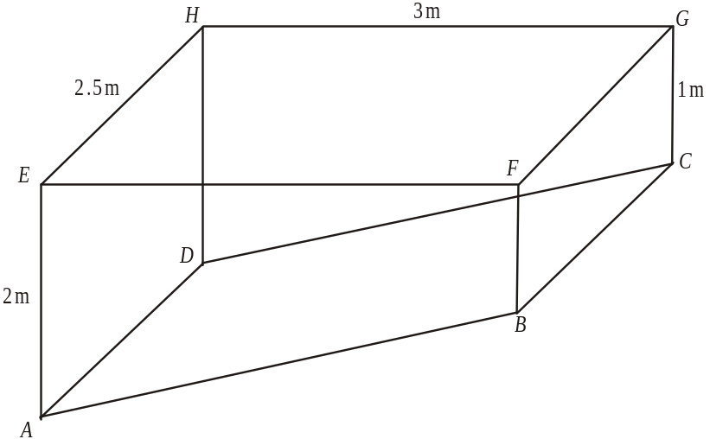

- Find the surface area of the water in the pool. Express your answer in m².

1 mark

- Find the length of the base of the pool; that is, find the length AB in metres, correct to one decimal place.

1 mark

- Find the volume of the pool. Express your answer in m³.

1 mark

- Find the angle BAE. Express your answer to the nearest degree.

1 mark

Question 2

The diagram below shows the decking that adjoins two sides of the pool.
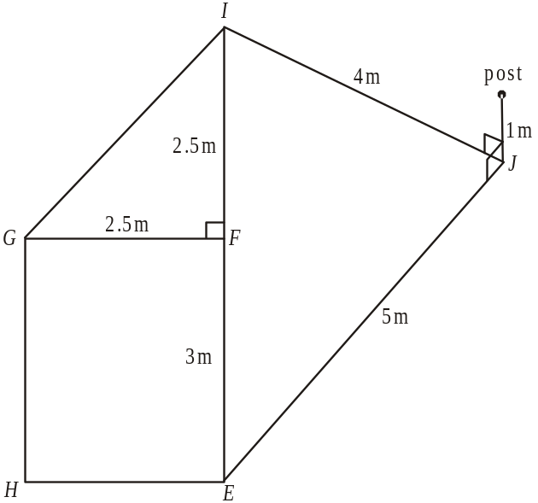

The boundary of the decking runs along sides EJ, JI and IG.
The length of side EJ is 5 metres, and the length of side JI is 4 metres. The distance from the corner of the pool at F to point I is 2.5 metres. A vertical post of height 1 metre is at point J.

- Find angle EJI. Express your answer in degrees correct to one decimal place.

1 mark

- Find the total area of decking. Express your answer in m², correct to one decimal place.

2 marks

- Find the angle of elevation of the top of the vertical post from point E. Express your answer to the nearest degree.

1 mark

Question 3

The other two sides of the pool are adjoined by two triangular areas of lawn indicated in the diagram below as triangles GHP and EHQ.

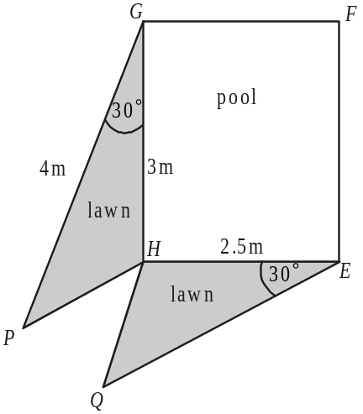

Triangles GHP and EHQ are similar and the area of triangle GHP is 3 square metres.

- Find the area of triangle EHQ. Express your answer in square metres.

2 marks

- Find angle EQH expressed to the nearest degree.

2 marks
Question 4

The pool is attached to a holiday apartment, which is one of three such apartments on a large property. The diagram below shows a plan of the property including the three apartments located at points K, M and N.
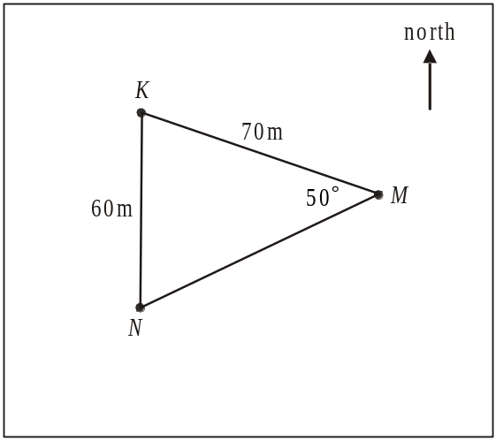

Apartment N is 60m due south of apartment K. Apartment M is 70m from apartment K and 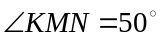.

- Find the distance from apartment M to apartment N. Express your answer in metres correct to 3 decimal places.

1 mark

- Find the bearing of apartment K from apartment M. Express your answer to the nearest degree.

2 marks
Total 15 marks
Module 3: Graphs and relations

If you choose this module all questions must be answered.

Question 1

Jane runs an on-line business selling baby blankets for $120 each.
Let n be the number of blankets Jane sells.

- Write an equation for R, the revenue Jane earns for selling n blankets.

1 mark

The graph below shows the graph of R, the revenue Jane earns for selling n blankets.
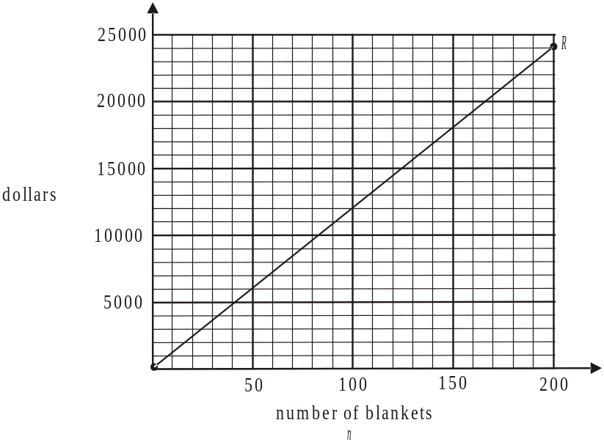

The cost, C, in dollars of producing n blankets is given by .

- Draw the graph of on the set of axes above.

1 mark

- How many blankets does Jane need to sell to break even?

1 mark

- If Jane made a profit of $4 200, how many blankets had she sold?

1 mark

Question 2

Jane often walks the 1.5km from her office to the warehouse.
The distance-time graph below shows Jane’s distance, d in km, from her office t minutes after she leaves it to walk to the warehouse one day.
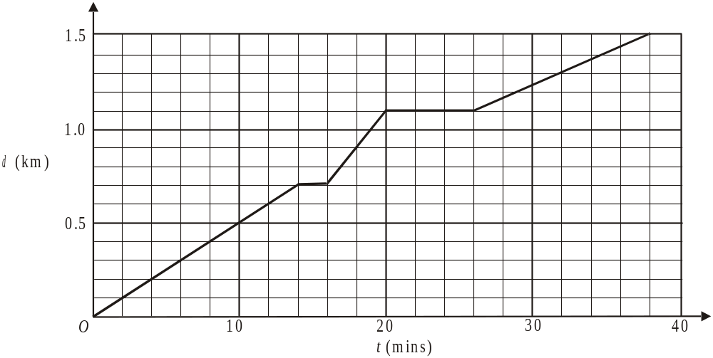

- What was Jane’s average speed, in km/min, for the entire walk. Express your answer correct to two decimal places.

1 mark

- What was the total length of time, in minutes, for which Jane was stationary during her walk?

1 mark

- During which interval of time after Jane left her office was she walking fastest?

1 mark

The equation of the graph during the interval of time between 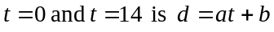.

- Find the values of a and b.

2 marks

Question 3

Jane also sells special occasion baby robes.
Let x be the number of blankets she sells each week.
Let y be the number of robes she sells each week.
Jane has a contract with a large department store which has a fixed weekly order for blankets and robes.
The constraints Jane has are

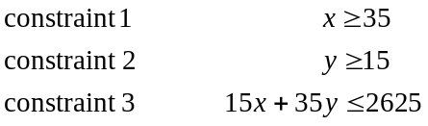

Constraint 3 relates to the machine time, in minutes, available per week to produce the blankets and robes.

- How many minutes of machine time does it take to produce a robe?

1 mark

The lines 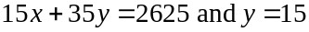 are drawn on the graph below.

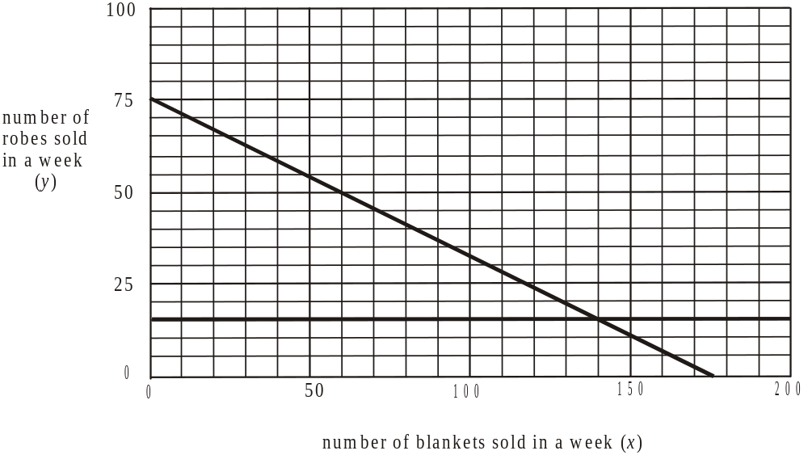

- Draw the line on the graph above.

1 mark

- Given the constraints she has, what is the maximum number of blankets that Jane can sell in a week?

1 mark

Jane makes a profit of $70 for selling a blanket and $90 for selling a robe.

- Find the number of blankets and robes she needs to sell in a week to make a maximum profit.

2 marks

- What is the maximum profit Jane can make in a week?

1 mark
Total 15 marks

Module 4: Business-related mathematics

If you choose this module all questions must be answered.

Question 1

The price of a dishwasher in a store is $1265.
This price includes a 10% Goods and Services Tax (GST).

- How much GST is included in the price of the dishwasher?

1 mark

- If a customer purchases the dishwasher using a particular type of credit card, an extra charge of 1.5% of the selling price will apply.
What would a customer pay in total if she paid for the dishwasher using this type of credit card?

1 mark

- A salesman in the store tells a customer that if he were to buy the dishwasher today, the price would be $1175.
Find the percentage discount on this deal. Express your answer as a percentage correct to 1 decimal place.

1 mark

Question 2

A commercial coffee machine was purchased for $7800.

- It is to be depreciated using the reducing balance method at the rate of 17% per annum.
What is the value of the coffee machine after 6 years?

1 mark

- Alternatively, the machine could be depreciated using the unit cost method at the rate of 14 cents per cup of coffee produced.

  - How many cups of coffee would need to be produced so that the machine is written off with a depreciated value of $0? Express your answer to the nearest whole number of cups.

  - Given that the machine is expected to produce 10 000 coffees each year, what would its depreciated value be after three years?

marks

- Suppose the machine is depreciated using a flat rate method of depreciation at a rate of 20% per year.
Comparing this method of flat rate depreciation and the unit cost method described in part b., by how much more does the flat rate method depreciate the coffee machine each year?

1 mark

Question 3

A man has $60 000 to invest.

- He could invest it in a bank account earning compound interest of 4.2% per annum calculated quarterly.
How much would his investment be worth after five years?

1 mark

- He could invest it in an annuity earning interest of 4.8% per annum compounding quarterly and he would be paid $2 000 each quarter.

- What is the balance of his investment remaining in the annuity after 5 years?

- How long would this annuity last? Express your answer in years, correct to one decimal place.

marks

- He could invest the $60 000 in a perpetuity with an interest rate of 4% per annum calculated monthly.

- How much would the man receive monthly?

- What would the remaining balance of this investment be after 5 years?

marks

Question 4

A couple borrow $135 000 which they plan to fully repay in equal six monthly instalments of $9 285.15 over 10 years.
Interest on the balance of the loan still owing, is to be charged to the loan account each six months.

- Calculate the annual interest rate on this loan.

1 mark

Interest rates change and the couple now have to pay 7% per annum interest for this loan.

- The couple fail to make any payments on the loan in the first year.

- Show that the amount that they owe at the end of the first year, to the nearest dollar, is $144 615.

- At the end of the first year they enter an arrangement with the bank to pay just the interest, each six months, on the amount that they now owe.
Find this interest payment.

marks
Total 15 marks

Module 5: Networks and decision mathematics

If you choose this module all questions must be answered.

Question 1

On a golf course, nine drinking fountains are scattered throughout the course. They include one at the clubhouse and the other eight at the start of various holes around the course.
The nine drinking fountains are shown as vertices on the network below. The shortest distance between them, in metres, is shown on the edges of the network.

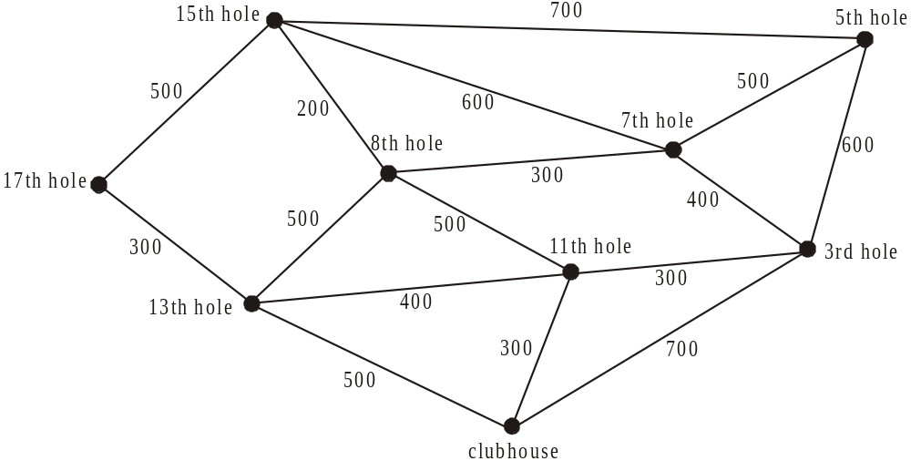

- What is the shortest distance, in metres, between the clubhouse and the start of the 5th hole?

1 mark

- A boy walks around the golf course. The route he takes passes just once along each edge of the network shown in the diagram above. He starts at the drinking fountain located at the clubhouse.

- At the start of which hole does he finish?

- What is the mathematical term that describes the route taken by the boy?

marks

- The pipes connecting the nine drinking fountains are to be replaced with new piping of least possible length.

- On the diagram of the network below, show where the new pipes should be laid so that the nine fountains are connected to each other and the total length of piping is a minimum.

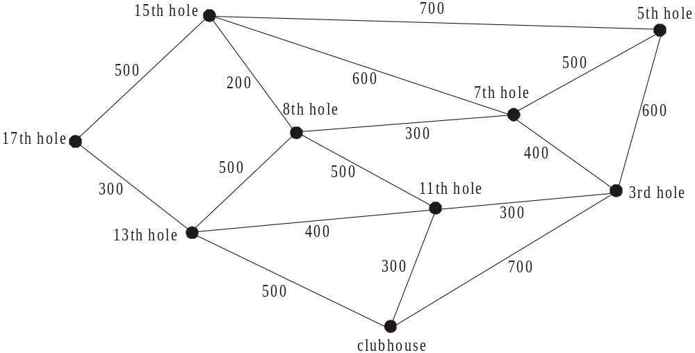

- What is the minimum length of piping required?

marks

Question 2

Ground staff at the golf course are routinely asked to prepare the tees (T), greens (G), bunkers (B) and fairways (F).
The fastest times, in minutes, that four of the ground staff; Euan, Pete, Glyn and Katrina can perform such tasks are shown in Table 1 below.

 | Euan | Pete | Glyn | Katrina
T | 40 | 36 | 45 | 42
G | 54 | 48 | 51 | 50
B | 22 | 29 | 30 | 25
F | 80 | 78 | 85 | 81
Table 1

An allocation of one task to one member of the ground staff is made, so that the time taken to complete the four tasks is a minimum.
The head of the ground staff uses the Hungarian algorithm to achieve this.
Tables 2 to 5 below show the tables he creates in order to find the optimal allocation.
 | Euan | Pete | Glyn | Katrina
T | 4 | 0 | 6 | 4
G | 6 | 0 | 0
B | 0 | 7 | 5 | 1
F | 2 | 0 | 4 | 1

 | Euan | Pete | Glyn | Katrina
T | 4 | 0 | 9 | 6
G | 6 | 0 | 3 | 2
B | 0 | 7 | 8 | 3
F | 2 | 0 | 7 | 3

Table 2 Table 3
 | Euan | Pete | Glyn | Katrina
T | 3 | 0 | 5 | 3
G | 6 | 1 | 0 | 0
B | 0 |  | 5 | 1
F | 1 | 0 | 3 | 0

 | Euan | Pete | Glyn | Katrina
T |  | 1 | 6 | 4
G | 7 | 2 | 1 | 1
B | 1 | 9 | 6 | 2
F | 2 | 1 | 4 | 1

Table 4 Table 5

Tables 3 - 5 are incomplete. Each of them has a shaded cell with a missing element.

- Complete each of the Tables 3 - 5 by writing in the missing element.
3 marks
- Complete the allocation of the four ground staff to a particular preparation task so that the four tasks are completed in minimum time.

Ground staff | Task
Euan
Pete
Glyn
Katrina | 2 marks

Question 3

On competition days at the golf course, there are fifteen additional activities that ground staff have to complete over and above their usual work.
These fifteen additional activities together with their completion time in minutes are shown on the directed network below. A dummy activity is also shown which starts at the end of activity G.
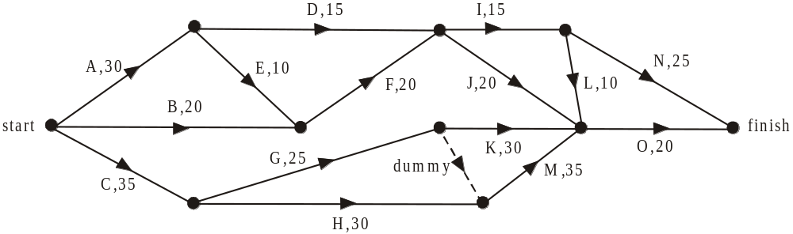

- Write down the immediate predecessor(s) of activity M.

1 mark

- What is the earliest start time for activity J?

1 mark

- What is the latest start time for activity A?

1 mark

- Write down the activities, in order, that form the critical path.

1 mark

- If activity G is delayed by 15 minutes, what will be the shortest time, in minutes that all fifteen activities can be completed in?

1 mark
Total 15 marks

Module 6: Matrices

If you choose this module all questions must be answered.

Question 1

George is constructing a watering system for his garden. There are three products he needs to do this, a control box (B), plastic piping (P) and connectors (C).
The prices in dollars, of these three products which are sold at rival hardware stores Gunnings and Pasters, are shown by matrix M below.

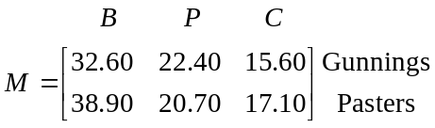

- Write down the order of matrix M.

1 mark

- Let matrix
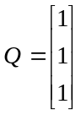
Find the matrix product R, where 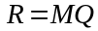.

1 mark

- In the context of this question, write down what the information in matrix R tells us.

1 mark
- Let matrix 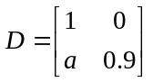
The matrix product DM gives us a matrix of order which gives the same prices for products B, P and C at Gunnings but a 10% discount on prices of products B, P and C at Pasters.
Find the value of a.

1 mark
Question 2

George has four hardware stores, Gunnings (G), Pasters (P), Joes (J) and Hardwareland (H) that he goes to regularly. He has a set route he always travels along to get from one store to the next.
Matrix A below shows George’s route from one store to the next.

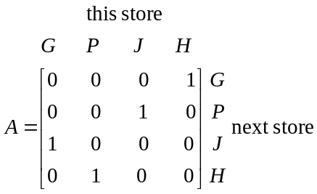

The 1 in row 2 column 3, for example, indicates that if George is at Joe’s store, then the next store he visits is Pasters.
The 0 in row 2 column 1, for example, indicates that George wouldn’t go from Gunnings to Pasters.

- One day, George was visiting all four of these hardware stores and he started at Hardwareland.
Write down the remaining three stores he visited, in the order he visited them.

1 mark

- On another day, when George visited all four stores, he finished at Hardwareland.
At which store did he start?

1 mark

Question 3

George is selling raffle tickets for his bowls club as well as for his local cricket and tennis clubs. The number of each type of ticket he is able to sell to his friends, his neighbours and his family is shown in table below.

 | friends | neighbours | family
bowls club raffle tickets | 7 | 4 | 12
cricket club raffle tickets | 6 | 10 | 14
tennis club raffle tickets | 8 | 7 | 18
Total sales | $68 | $79 | $148

Let the cost of a ticket

- in the bowls club raffle be $x
- in the cricket club raffle be $y
- in the tennis club raffle be $z

- Using this information, fill in the two missing elements in the matrix equation below.

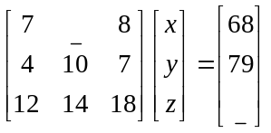
1 mark

- Find the cost of a cricket club raffle ticket using the matrix equation in part a..

2 marks

Question 4

For 2012, the 80 members of George’s bowls club had four options with regard to renewing their membership. They could pay online (O), in cash(C), by direct debit (D) or they could let their membership lapse(L).
The number of members choosing each of these options in 2012 is given in the matrix below.
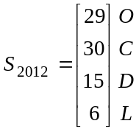
The way in which it was anticipated that members would change their renewal options in subsequent years is given by the transition diagram below.

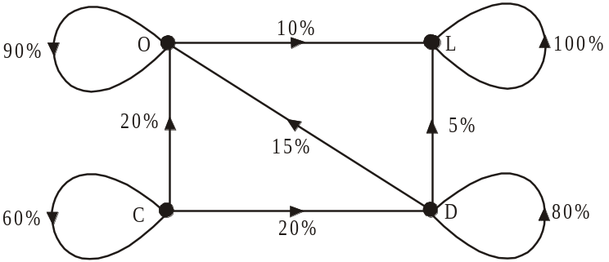

- i. How many members who paid their 2012 membership with cash are expected to pay online in 2013?

- Explain why no arrows in the diagram lead away from L to any of the other options.

marks

The transition matrix, T, representing the transition diagram is given below.

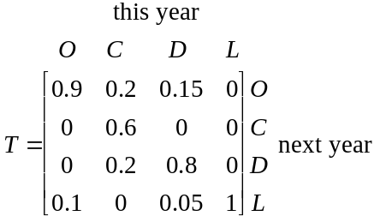

If this pattern of renewal were to continue, the number of members opting for a particular option in the nth year could be found by evaluating the state matrix 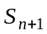 where

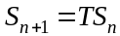

- Find 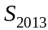.

1 mark

- Find the number of members who paid in cash in 2013.

1 mark

- In which year does the number of members renewing their membership online first exceed the total number who pay by other methods?

1 mark

- Find the number of members anticipated to be at the club long term?

1 mark
Total 15 marks

Further Mathematics Formulas

Core: Data analysis

standardised score: 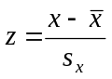
least squares line: 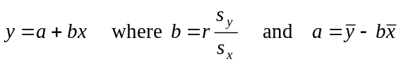
residual value: residual value = actual value – predicted value

seasonal index: seasonal index 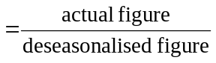

Module 1: Number patterns

arithmetic series: 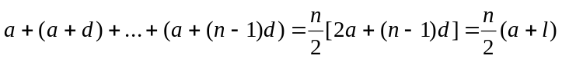
geometric series: 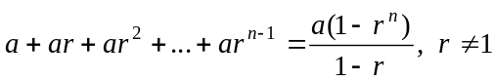
infinite geometric series: 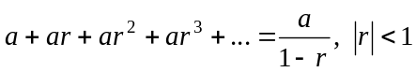

Module 2: Geometry and trigonometry

area of a triangle: 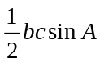
Heron's formula: 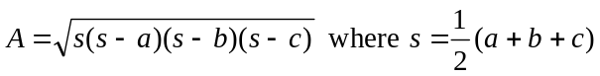
circumference of a circle: 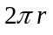

area of a circle: 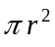

volume of a sphere: 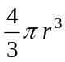
surface area of a sphere: 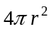

volume of a cone: 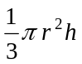
volume of a cylinder: 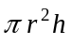

volume of a prism: 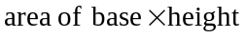
volume of a pyramid: 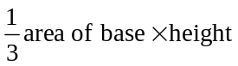

Reproduced with permission of the Victorian Curriculum and Assessment Authority, Victoria, Australia.
These formula sheets have been copied from the VCAA website www.vcaa.vic.edu.au
Pythagoras’ theorem 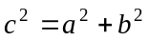

sine rule: 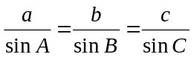
cosine rule: 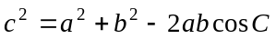

Module 3: Graphs and relations

Straight line graphs
gradient (slope): 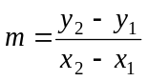
equation: 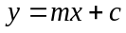

Module 4: Business-related mathematics

simple interest: 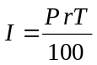
compound interest: 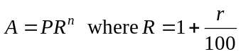
hire purchase: 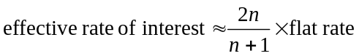

Module 5: Networks and decision mathematics

Euler’s formula: 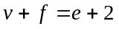

Module 6: Matrices

determinant of a 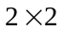 matrix 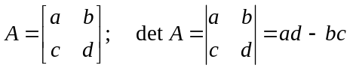
inverse of a matrix 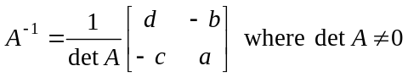

END OF FORMULA SHEET

Reproduced with permission of the Victorian Curriculum and Assessment Authority, Victoria, Australia.
These formula sheets have been copied from the VCAA website www.vcaa.vic.edu.au

